BBSSSA Athletics Championships

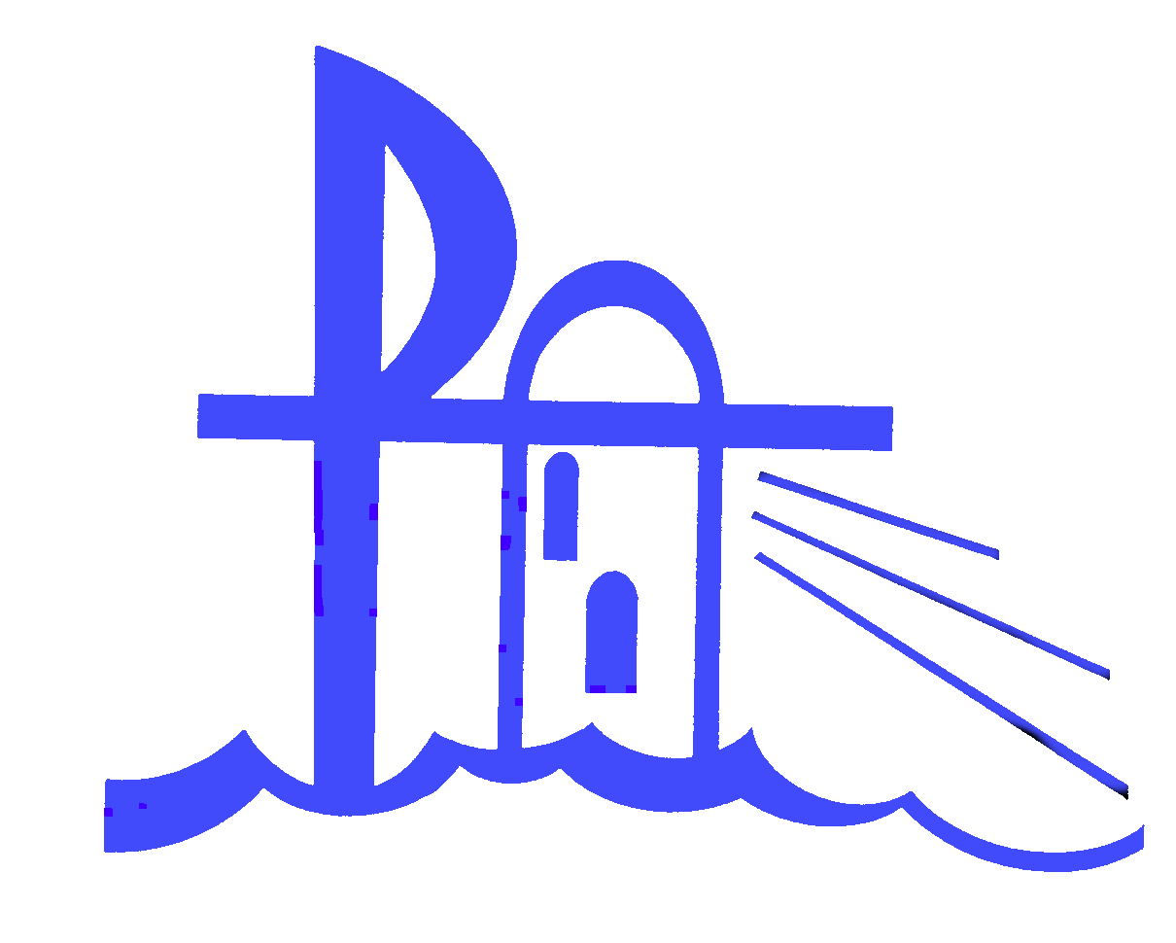
Catholic Schools Office
Diocese of Broken Bay
BROKEN BAY SECONDARY SCHOOLS
SPORTS ASSOCIATION

PARA ATHLETE ENTRY FORM

The following events will be held at the BBSSSA Athletics Carnival:

- 100 metres, 200 metres
- Long Jump, Shot Put, Discus

To be eligible for this event, you must have Official Classification.

Date: | Wednesday 17th August 2016
Venue: | Sydney Olympic Park Athletic Centre, Homebush Bay
Age: | Open
Time: | See program
Cost: | As set by your school
Closing Date: | Friday 5th August 2016
Entries to: | Your Sports Coordinator
Athlete’s Name:
 | Male Female (please circle)
Date of Birth:
 | Age as at 31st December 2016:
School:
Classification:
Events Entered:  (please tick) | - 100 metres | - 200 metres | - Long Jump
 | - Shot Put | - Discus
 | Please attach a copy of the Provisional Classification
The events listed below will also be available at CCC. Please tick if you wish to enter this event at NSW CCC Carnival Friday 16th September 2016
- 800m

